A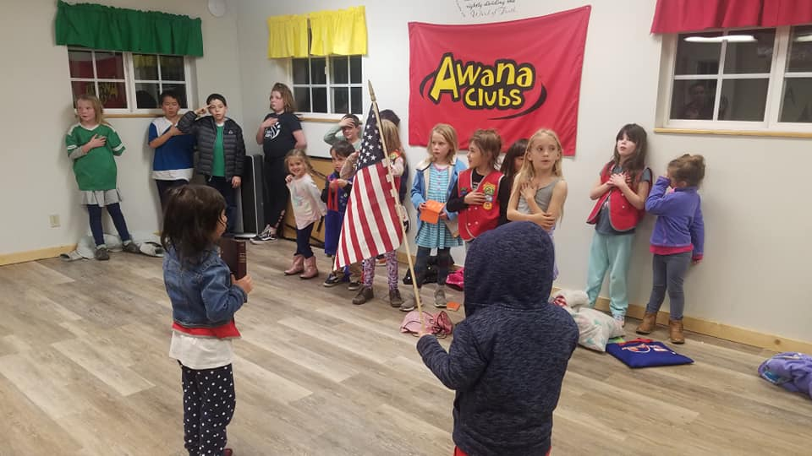ANAAT HOME
Mount Calvary Lutheran Church Online Resources:
Go to mclutheran.com to access all of our online services, meetings, and resources!
Awana at Home!

Our goal is to keep your family and the kids connected to the program, to their leaders, and to each other. We know that for most of these kids Wednesday night Awana is the "highlight" of their week - and our week too! So gather as a family, and “zoom” in with us each Wednesday night and let’s keep walking out this faith journey together – until we can meet again!

Instructions for your time together:
Step 1. Opening Pledges We will do this during our online large group meeting. If you will not be attending the meeting, here is a link to the Bible pledge on YouTube: https://www.youtube.com/watch?v=pGULZO6gh3Y and, of course, you know the pledge of allegiance. The last part is our Awana theme verse: 2 Timothy 2:15 https://biblepic.com/2_timothy/2-15.htm

Songs We will also do songs during our zoom meeting, but here are links to some of our favorite songs:
- The Fruit of the Spirit’s not a Coconut. (Tutorial) https://www.youtube.com/watch?v=e47FnjKaT3Q&t=6s
(Sing along) https://www.youtube.com/watch?v=gA-TMUDQ7us&t=38s2)

- Sea of Galilee https://www.youtube.com/watch?v=Jdv5gh7ebho

- My Lighthouse https://www.youtube.com/watch?v=K-WAg6h1Gs0

- Zoom Around the Room https://www.youtube.com/watch?v=kOXKWFOoETI

Prayer Requests – We always start with asking how everyone is doing, and if they have something they’d like us to pray about. Mom or Dad (or older sibling) make a list. You can pray together now or at the end of your time together.
Step 2. Handbook time:
- No matter which book your clubber is in, pick up where they left off. Walk through the section with them, reading and discussing together. If you have not been doing the book, now is a great to start at the beginning and just begin working through it with your child. It’s a fun and easy way to do family devotions together and there are some fun activities, too!
- If your child knows and is able to recite their verse, or section, that they have been working on this past week, take a video or picture and text it to their leader. You can also call your child’s club leader and have them recite the verse over the phone. Let the camera see the verse or section, lay the book down and say the verse. You may give your child 2 helps if they are a Cubbies or Sparks, and 1 help if they are older.
Step 3: Large Group time: Join in pledges, songs, and a game by tuning in for our zoom meeting on Wednesday nights at 6:00 PM Meeting ID 981 513 541

Step 4: Individual Club Breakouts: If you want your kids to see their friends and leaders, here is your chance!
Cubbies 5:30 PM Miss Tracy and Miss Vickey Meeting ID 948-443-227
Sparkies 6:30 PM Mr. Daryl Meeting ID 358 669 843
T & T 7:00 PM Miss Sophie and Mr. Andrew Meeting ID 321-102-100
Step 5: Close your time in prayer: Let one of your kids thank God for His Word and His love.
Step 6: Homework: During the week help your kids work on memorizing their new verse or section.

Need help? Let us know! Text 909-327-5354 (Miss Tracy)

Miss Tracy email tracyt@mclutheran.com Text: 909.327.5354

Miss Sophie email ejndzel@hotmail.com Text: 951.217.0930
Miss Vickey email vickey.england66@gmail.com Text: 909.844.0752
Mr. Daryl email daryljlohmeyer@gmail.com Text: 760.525.8721

You may want to print this out for your reference! In the coming weeks, I will just list some additional resources and announcements to supplement this page!

Take care, we love you, and please come to our zoom meetings because we miss your kids!

